

**KABARAK UNIVERSITY**

**LECTURER APPRAISAL SYSTEM**

**SCHOOL OF SCIENCE ENGINEERING AND TECHNOLOGY**

**INTE 424: PROJECT 2.**

**MAY – AUGUST SEMESTER 2023**

**INTE/MG/0988/09/19**

**BRAIN MUSUNGU KITHEKA**

**A project submitted in partial fulfilled for the requirement of a Bachelor of Information Technology**

# **DECLARATION**

**Declaration by the candidate**

I hereby declare that the proposed Lecture Appraisal System submitted to the school of Science Engineering and Technology, Kabarak University is result of original work carried by me.

**NAME: BRAIN MUSUNGU KITHEKA**

Sign………………………………. Date………………

# **COPYRIGHT**

All rights reserved. No part of this proposal may be reproduced, distributed or transmitted in an form by any means without prior written permission of the copyright owner except in the case of brief quotations reviews permitted by the copyright law. For the permission request, write to the author at the address below

**BRAIN MUSUNGU KITHEKA**

**KITHEKAMUSUNGU@GMAIL.COM**

# **ACKNOWLEDGEMENTS**

I would like to express my special thanks of gratitude to the School of Science and information technology for their able guidance and support to acquire the skills needed to complete this project work.

I would also like to express my special thanks of gratitude to my lecturer Mr. Ruoro, who gave me this opportunity to do this project and his support throughout the project work it would be hard without his involvement.

I would also like to express my gratitude towards my colleagues and members of the Kabarak community for their kind co-operation and encouragement, which I needed in order to complete the project proposal.

# **ABSTRACT**

The Lecturer Appraisal system will be implemented as a web-based application. It will be accessible to students and administrators. The system will be designed to be user-friendly and intuitive. It will also be scalable to accommodate large numbers of users. The system will be very dynamic and able to collect data a much reduced time without the need of manual formulation of evaluation results. The results of the evaluation will be used to improve the system and make it more effective. The proposed system has the potential to improve the quality of teaching in higher education. It will provide a more comprehensive and objective assessment of lecturers' performance, and if used as intended it will give the amazing results for lectures improvement. It also ensures anonymity of the students who are the target users but also ensures they are not given opportunity to provide wrong reports. This is ensuring students only can be able to evaluate courses which they are doing.

Table of Contents

**DECLARATION** i

**COPYRIGHT** ii

**ACKNOWLEDGEMENTS** iii

**ABSTRACT** iv

**CHAPTER INTRODUCTION.** 1

**1.2 Background study.** 1

**1.2.1 Current system.** 3

**1.3 Problem statement.** 3

**1.4 Purpose of the study.** 4

**1.5 Objectives of proposed system.** 5

**1.9.1 The main objective.** 5

**1.9.2 Specific objectives.** 5

**1.6 The proposed system.** 5

**1.6.1 Modules of the system.** 5

**1.7 Justification of the study.** 5

**1.8 The feasibility study.** 6

**1.8.1 Technical visibility.** 6

**1.8.2 Economic feasibility.** 6

**1.8.3 Operational feasibility.** 6

**1.9 The scope and limitations of the project.** 6

**CHAPTER 2.0 LITERATURE REVIEW** 7

**2.1 Introduction** 7

**2.2: Design a customizable Lecture Appraisal system.** 7

**2.2: Enhancing the Quality of lecture evaluations.** 7

**2.3: Stream lining the appraisal process.** 8

**2.4: Improving analysis and Presentation of Appraisal Results.** 8

**CHAPTER 3.0 RESEARCH DESIGN AND METHODOLOGY** 9

**3.1 Introduction.** 9

**3.2 Research design methods.** 9

**3.3 Location of the study.** 9

**3.4 Population of the study.** 9

**3.5 Sampling and sample size.** 9

**3.5.1 Sampling procedure.** 9

**3.5.2 Sample size.** 9

**3.6 Data collection procedures.** 10

**3.7 System analysis and design.** 11

**3.7.1 Context level diagram.** 11

**3.7.2 DFD Diagram** 12

**3.7.3 E-R Diagram** 13

**3.8 System Testing** 14

**CHAPTER4: SYSTEM IMPLEMENTATION AND DEPLOYMENT.** 15

**4.1: System description** 15

**4.2 The Admin page** 15

**4.2.1 Reports page.** 15

**4.2.2: lecture and student management page.** 16

**4.2.3: Forms page.** 17

**4.3: Student module.** 18

**4.3.1 Guidelines page.** 18

**4.3.2 The assessment page.** 19

**4.4 Access Control module.** 20

**CHAPTER 5: CONCLUSION AND RECOMMENDATIONS.** 21

**5.1: Conclusions.** 21

**5.2: Recommendations.** 21

**5.3: Appendix.** 22

**5.3.1:Appendix1- References** 22

**5.3.2 Appendix 2- Project Schedule.** 23

**5.3.2: Appendix 3- Project budget** 23

**Table of figures**

Figure 1 Context level diagram 10

Figure 2 Data flow diagram 11

Figure 3 Entity relation diagram 12

Figure 4Example of reports page 13

Figure 5 Example of lecture management page 14

Figure 6 Example of the question template 15

Figure 7 Example of student login page 16

Figure 8 Example of evaluation page 17

**Tables used.**

Table 1Project schedule 21

Table 2 Project Budget 21

# **CHAPTER INTRODUCTION.**

.The Lecture appraisal system is a system designed to provide administrators with a powerful toolset, empowering them to generate customized evaluation questions, access to appraisal results, and gain a valuable insights into the teaching and learning process. The core functionality of the system revolves around empowering administrators to tailor evaluation questionnaires according to the unique requirements of each course. With an easy interface, administrators can effortless create, modify and organize evaluation questions, ensuring they align perfectly with the course content and objectives.

Students, on the hand, will be granted access to evaluate only those subjects for which they are registered. This ensures that feedback remains specific and relevant to each student’s educational experience, promoting accuracy and fairness in the appraisal process. The system features a comprehensive results analysis that enables administrators easily make data driven decisions. With the ability to analyze results performance trends, strengths, and areas of improvement, educators can implement timely interventions and refine teaching methodologies for enhanced student engagement and academic outcomes.

The system offers an unparalleled opportunity for educational institutions to elevate the quality of teaching and learning. With administrators empowered to generate custom evaluation questions and access real-time results and students provided with targeted evaluation opportunities, the Lecture Appraisal system fosters an environment of continuous improvement and accountability.

## **1.2 Background study.**

In today’s rapidly evolving educational landscape, the importance of evaluating teaching effectiveness and gathering student feedback cannot be overstated. Traditional paper-based evaluation methods have their limitations in terms of efficiency, data accuracy, and accessibility. Recognizing these challenges, I propose the development and implementation of a state-of-the-art lecture Appraisal System that addresses this concerns while providing educational institutional with a robust and user friendly toolset for course evaluation.

Institutions of higher learn continuously strive to enhance the quality of education provided to their students. A key aspect of this improvement process is obtaining accurate and timely feedback on courses and instructors. However, the manual administration or sorting of evaluation forms is often cumbersome and time consuming for both students and administrators. The need for an automated and efficient appraisal system arises to streamline the process and maximize the value of student feedback.

Traditional evaluation systems typically employ standardized questionnaires, which may not fully capture the unique aspects and objectives of individual courses. The Lecture Appraisal will allow administrators to create tailored evaluation questionnaires for each subject, aligning the questions with course content, instructional approaches, and learning outcomes. This customization will yield more comprehensive and relevant feedback for educators, enabling the to adapt their teaching methodologies to meet the specific needs for their students.

The system will provide administrators with a system to access real-time results. This feature allows immediate visibility of courses allows immediate visibility into the effectiveness of the courses and instructors, facilitating data-driven decision-making. Through sophisticated data analysis tools, administrators can identify trends, strengths, and areas of improvement, leading to continuous enhancements in teaching practices and overall educational quality. Considering the relevance of the appraisal data, our system will allow students to evaluate only the subjects they are registered for. This targeted approach reduces the chances of indiscriminate feedback and enhances the credibility of the appraisal process.

### **1.2.1 Current system.**

Traditionally educational institutions have relied on traditional paper-based appraisal systems to gather student feedback and evaluate faculty performance. In this approach students are provided with printed evaluation forms at the end of the course, where they are ask to rate various aspects of the course and instructors teaching methods. While these systems have been in use for many years, even now, they come with several limitations such as they are time consuming for process of distributing and collecting the physical forms and use of standardized questionnaires may not capture specific nuances of different courses. They are also labor intensive, further delaying the dissemination of evaluation results and hindering timely improvements in teaching and learning process.

Recognizing the limitations of traditional paper based systems, many educational systems institutions have transitioned to online evaluation systems. Online platforms offer significant advantages, including increased efficiency, faster data collection, and reduced administrative burden. But this did not solve the standardized questions as questions have to be accessed from third part API’s or being hard coded in school portals. However, to fully realize potential of appraisal systems, it is essential to address technical challenges related to rigidity and dynamic of the appraisal systems to fit our need and the needed time.

## **1.3 Problem statement.**

The current problem with online lecture appraisal systems includes lack of flexibility in creating and customizing evaluation questionnaires. Many existing systems offer a limited set of predefined questions, which may not adequately capture the specific nuances and learning objectives of individual courses. As a result, the feedback gathered from students may not be as detailed, relevant, or actionable as desired. Educators require the ability to tailor evaluation questions according to the unique characteristics of their course teaching styles. Customizable questions are essential to gain deeper insights into various aspects of the learning experiences, such as course content, instructional methods, and overall student engagement. Without this customization, the appraisal system may fall short in delivering comprehensive feedback that can drive meaningful improvements in teaching and learning.

Traditional paper-based appraisal systems suffer from inherent inefficiencies that impact the entire evaluation process. Distributing paper evaluation forms to students at the end of a course consumes valuable class time, potentially disrupting the final lectures and assessments. Furthermore collecting the physical forms from every student can be time-consuming and cumbersome, particularly in large classes. This delayed collection can result can result in postponing data analysis and feedback dissemination to faculty members, affecting their ability to make timely improvements. In addition, paper-based appraisals may lead to lower participation rate due to students misplacing or forgetting to submit their forms, thereby diminishing the overall validity and reliability of the feedback collected.

After collecting paper-based appraisal forms, administrators and faculty members are burdened with tedious tasks of manually sorting and organizing the physical documents. This process can be labor-intensive, especially in institutions with a substantial number of courses and students. The manual sorting and data entry of appraisal forms consume considerable administrative resources and may delay the generation of evaluation reports. Furthermore, the risk of errors in data entry exists, potentially leading to inaccuracies in the evaluation results. The time spent on these manual administrative tasks could be better utilized for analyzing appraisal data, identifying areas for improvement, and implementing effective strategies to enhance quality of education. An efficient online lecture appraisal system must address these challenges and provide streamlined processes for data collection, analysis, and reporting to optimize the evaluation process and maximize its impact on academic excellence.

## **1.4 Purpose of the study.**

The purpose of the study is to address the inefficiencies associated with the current paper-based appraisal process and manual sorting of appraisal forms. The introduction of the Lecture Appraisal System aims to streamline the entire appraisal process, from data collection to reporting, through an online platform. By transitioning from paper-based to digital evaluations, the study seeks to eliminate the need for physical distribution and collection of evaluation forms, saving valuable class time and reducing administrative burden. This shift to an online system not only increases participation rate but also allows for faster data collection and analysis.

Also another crucial purpose of this study is to address the current limitations on online lecture appraisal systems, specifically the lack of customizable questions. The goal is to develop an innovative Lecture Appraisal System (LAS) that empowers educators and administrators to create and tailor evaluation questionnaires according to the unique characteristics of each course and instructor. By providing this flexibility, the LAS aims to gather more comprehensive and relevant feedback from students, enabling educators to gain valuable insights into various aspects of the teaching and learning process. Through this customization, the study seeks to enhance the effectiveness of faculty evaluations, leading to more targeted and actionable feedback.

## **1.5 Objectives of proposed system.**

### **1.9.1 The main objective.**

1. Develop a customizable Lecture Appraisal System

### **1.9.2 Specific objectives.**

1. To develop a system to enhance the quality of Lecture evaluations.
2. To implement a system those streamline the appraisal process.
3. To implement a system that improves analysis and presentation of appraisal results.

## **1.6 The proposed system.**

The proposed Lecture Appraisal System (LAS) aims to revolutionize the way educational institutions gather and analyze student feedback, leading to enhanced teaching practices and overall academic excellence. The system’s main objective is to develop a customizable platform that caters to the unique characteristics of each course allowing tailored evaluation questionnaires. By achieving these LAS empowers administrators to obtain more relevant and insightful feedback, enabling to make data-driven decisions for continuous improvements.

### **1.6.1 Modules of the system.**

* **Administrator module**

The module provides administrator related functionality which include managing students in students page, managing lectures in lectures page, forms page to modify questionnaires, report page to see all evaluation results and analysis page to view analyzed results, course page to manage courses.

* **Student module**

It contains interface for students to login and evaluate lectures from units they are currently enrolled in. It allows students to provide valuable feedback on the quality of the lectures, enabling administrators to generate reports for the appraisal results.

## **1.7 Justification of the study.**

The proposed study on developing a customizable Lecture Appraisal System (LAS) is of utmost significance in the field of education. Traditional paper-based appraisal methods often suffer from limited flexibility and efficiency, leading to generic feedback and delayed data analysis. By addressing these shortcomings and introducing innovative LAS, this study seeks to improve the overall quality of education through data driven decision-making. The customization of the LAS empowers educators to create tailored evaluation questionnaires, allowing them to gather specific and relevant feedback from students. This personalized approach enables instructors to identify areas for improvement and optimize their teaching methodologies, ultimately enhancing the learning experience for students.

Furthermore, the need for this study arises from the growing importance of the data driven decision-making in educational institutions. As institutions strive to offer high quality education and maintain competitive edge, having access to comprehensive and timely feedback on teaching effectiveness is crucial. The proposed LAS will provide educators with the necessary tools to enhance their teaching methodologies. Tailor their courses to meet students needs, and address areas of improvement. Ultimately, the study’s justification lies in its potential to transform educational practices, fostering a more response and adaptive approach to teaching, and cultivating a culture of continued improvements that benefits the entire education community.

## **1.8 The feasibility study.**

### 1.8.1 Technical visibility.

The technical feasibility requires one to have knowledge in coding the following languages; Python Flask framework, CSS, HTML, advanced database skills and basic computer programming.

## **1.8.2 Economic feasibility.**

The development of the required system requires the following funding; Ksh 2000 for research and travel and Ksh500 for CASE tools and testing process, both adding to Ksh 2500 in total to complete the project.

### 1.8.3 Operational feasibility.

The operational feasibility of the Smart Lecture Appraisal System is a computer system or mobile phone with environment of at least 50MB storage and internet access. A little literacy level is also needed.

## **1.9 The scope and limitations of the project.**

While the proposed Lecture Appraisal system (LAS) aims to address several crucial aspects of education evaluation, it is essential to acknowledge certain scope limitations. First, the system effectiveness relies on the active participation of student, and while efforts may be made through sending emails to students the study cannot guarantee complete participation. Additionally, the LAS implementation will require support and cooperation of faculty members and administrators to ensure successful adoption and integration with existing institutional processes. Last, while the LAS will offer a customizable platform for evaluation questionnaires, it may not capture every unique aspect of the course or teaching style. Administrators will need to strike a balance between comprehensive feedback and practicality of the questionnaires length.

# **CHAPTER 2.0 LITERATURE REVIEW**

## **2.1 Introduction**

The quality of education in any institution is closely linked to the effectiveness of its teaching methodologies. Gathering comprehensive and timely feedback from students plays a vital role in continuously improving teaching practices and enhancing the overall learning experience. To address the limitations of traditional paper-based evaluation methods and streamline the available appraisal process, I propose to develop an advanced Lecture Appraisal System. This customizable platform aims to empower educators to create tailored evaluation questionnaires that align precisely with their courses’ unique characteristics, instructional methods, and learning objectives. Through an online interface and automated data analysis, the LAS seeks to enhance the lecture evaluations, improve the analysis and presentation of appraisal results, and streamline the entire Appraisal process. This study outlines the objectives and scope of the proposed Lecture Appraisal process, offering an innovative solution to foster a culture of data driven decision making and continuous improvement in education institutions.

## **2.2: Design a customizable Lecture Appraisal system.**

By creating dynamic appraisal systems for questionnaires it enables administrators to enhance the quality of evaluations. By allowing for the customization of evaluation questionnaires, administrators can solicit targeted feedback from student, gaining valuable insights into the used teaching methodologies (Johnson, 2022). By allowing for the customization will lead to more relevant and meaningful feedback, enabling lectures to identify areas of strength and areas that require improvement, ultimately promoting excellence in education.

## **2.2: Enhancing the Quality of lecture evaluations.**

To achieve the objective of enhancing the quality of lecture evaluations, the Lecture Appraisal System (LAS) will enhance the quality of lecture evaluations through a dynamic and customizable questionnaire interface (Johnson, 2018). Administrators will have flexibility to craft evaluation questions that precisely match the course content, instructional methods, and learning objectives. This customization allows students to provide more relevant and valuable feedback, offering lecturers with insights into effectiveness of their teaching methodologies. The LAS will also incorporate open ended questions to encourage qualitative feedback, providing a deeper understanding of the students’ perceptions and needs. By implementing a comprehensive evaluation process, lecturers will gain a clear picture of their teaching effectiveness, identifying areas of success and those that require improvement.

.

## **2.3: Stream lining the appraisal process.**

To streamline the appraisal process, the Lecture Appraisal System will transition from the traditional paper-based evaluations to an online platform (Smith and Williams, 2019). Students will access the appraisal system through a user friendly web interface, eliminating the need of distributing physical evaluations forms. Automated email reminders can be used prompt students to complete their evaluations, ensuring higher participation rates and timely data collection. Once evaluations are submitted, the system will automatically sort the results, significantly reducing the administrative burden and unnecessary expenditures for generation of evaluation results. This streamlined approach saves valuable time for both students and administrators, enabling easy generation of feedback for continuous improvement.

## **2.4: Improving analysis and Presentation of Appraisal Results.**

The Lecture Appraisal system will implement advanced data analysis and presentation of appraisal results.(Brown and Lee, 2020). Data-analysis will allow administrators to extract meaningful insights from the appraisal data with a very short duration. The system will generate comprehensive reports that highlight key performance indicators, such as average ratings, strengths, weaknesses from the appraisal data. This reports will facilitate data driven decision-making, enabling administrators to compare appraisal results across courses, departments, and instructors, supporting institutional-level evaluations and fostering a culture of continuous improvement.

# **CHAPTER 3.0 RESEARCH DESIGN AND METHODOLOGY**

## **3.1 Introduction.**

Methodology is the systematic, theoretical analysis of the methods applied in field study. This chapter explains various methodologies that were used in gathering data and analysis which are relevant in research. The methodologies will include areas such as the location of the study, research design, sampling and sample size, types of data, data collection methods and its management.

## **3.2 Research design methods.**

The chosen research for this study was a descriptive research design. Descriptive research seeks to describe the current status of an identified variable, and in this case, it focused on understanding the factors that affect student expression in lecture evaluation and the challenges faced by administrators in collecting appraisal results. Data was collected from respondents within the study area, likely students and administrators from educational institutions, to gain insights into their experiences and perspectives regarding lecture evaluations. This research design was selected because it aimed to provide a comprehensive overview of the current situation without diving into the underlying reasons behind the observed phenomena. By focusing on “what” rather than “why” the study aimed to generate practical information and recommendations to improve student expression in lecture evaluations and streamline the appraisal data collection process for administrators.

## **3.3 Location of the study.**

The study was carried out in Kabarak University main campus and town campus, Nakuru county, Kenya. I choose this area because it was easily accessible, has Lecture Appraisal program regularly, and has a favorable social-political influence for research influence. Hence, there is possibility of obtaining all necessary and relevant data for the research.

## **3.4 Population of the study.**

The population of the study covers all the cases of individuals or things or elements that fit a certain specification. The sample population used in the study was about 40 respondents, of which 3 were administrators, 37 were students who were available to participate for my research. With higher education schools all over the country, the research couldn’t reach all these subjects but the sample chosen had the needed impact on the whole population.

## **3.5 Sampling and sample size.**

### **3.5.1 Sampling procedure.**

The sampling procedure used in identifying the sample size was convenience sampling and random purposive sampling. Convenient sampling was used to select administrators who had time and were willing to participate in the research. Random sampling was used in students because of their large numbers and ease of availability.

### **3.5.2 Sample size.**

The sample size that was used in the study included 40 respondents. Among the sample population, three were administrators; thirty seven were students from both Kabarak university Main campus and town campus.

## **3.6 Data collection procedures.**

The methods used in collecting data were through interviews, where data was collected through oral and verbal communication with the respondents. I had to notify the respondents on what they were being interviewed for and what would be published. Most except for administrators were readily available which for the administrators I had to fit to their schedule to avoid disturbing them performing their duties. The data from the respondents was collected through recording, those who were not comfortable with recording I had to note down on my note book. I agreed with the respondents to keep their names anonymous which I will keep. The only challenge I got was time of fixing meeting at the respondent’s convenient time.

All the data as achieved through;

**Questionnaires**

Forms were issued to students and admnstrators to get their views and recommendations about the proposed Lecture Appraisal systems.

**Surveys**

Surveys were administered, both online and physical to gather information.

**Interviews.**

Live interviews were conducted tostudents about their views on the current Lecture Appraisal systems in place.

**Google search**

Other data was collected through research on online platforms like google, where I got to learn more about other existing systems and implmentation tecniques.

## **3.7 System analysis and design.**

### **3.7.1 Context level diagram.**

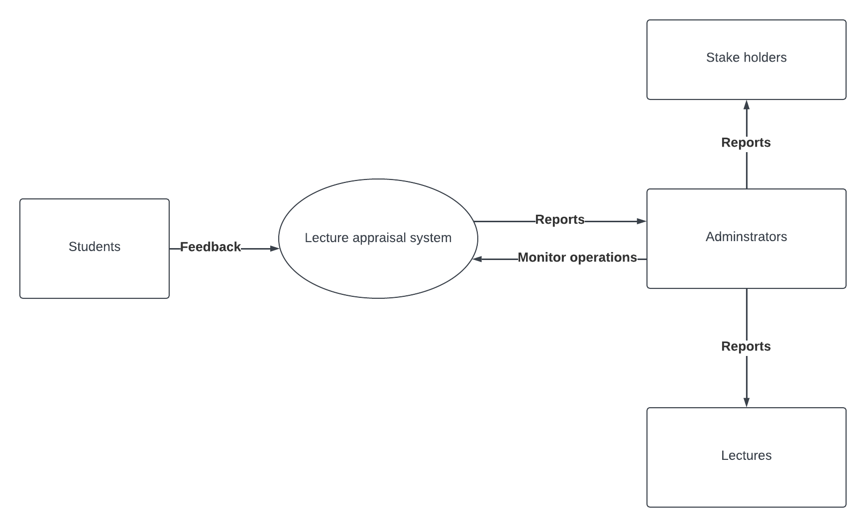

Figure 1 Context level diagram

### **3.7.2 DFD Diagram**

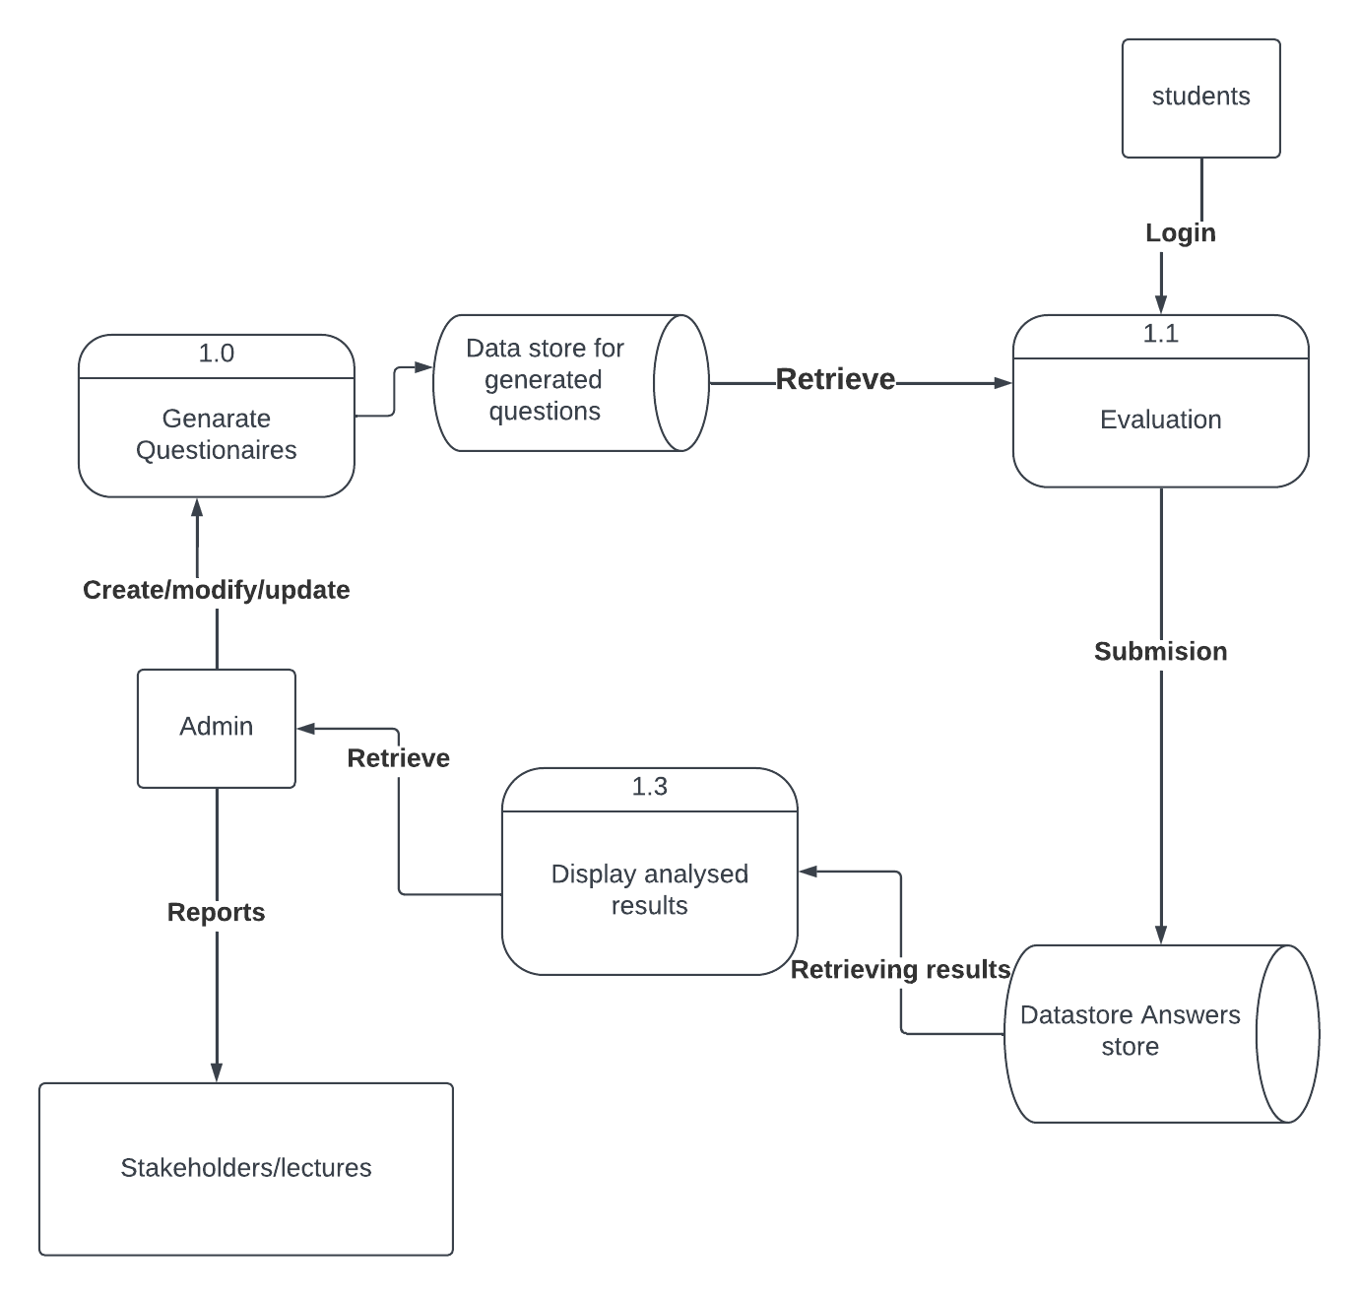

Figure 2 Data flow diagram

## **3.7.3 E-R Diagram**

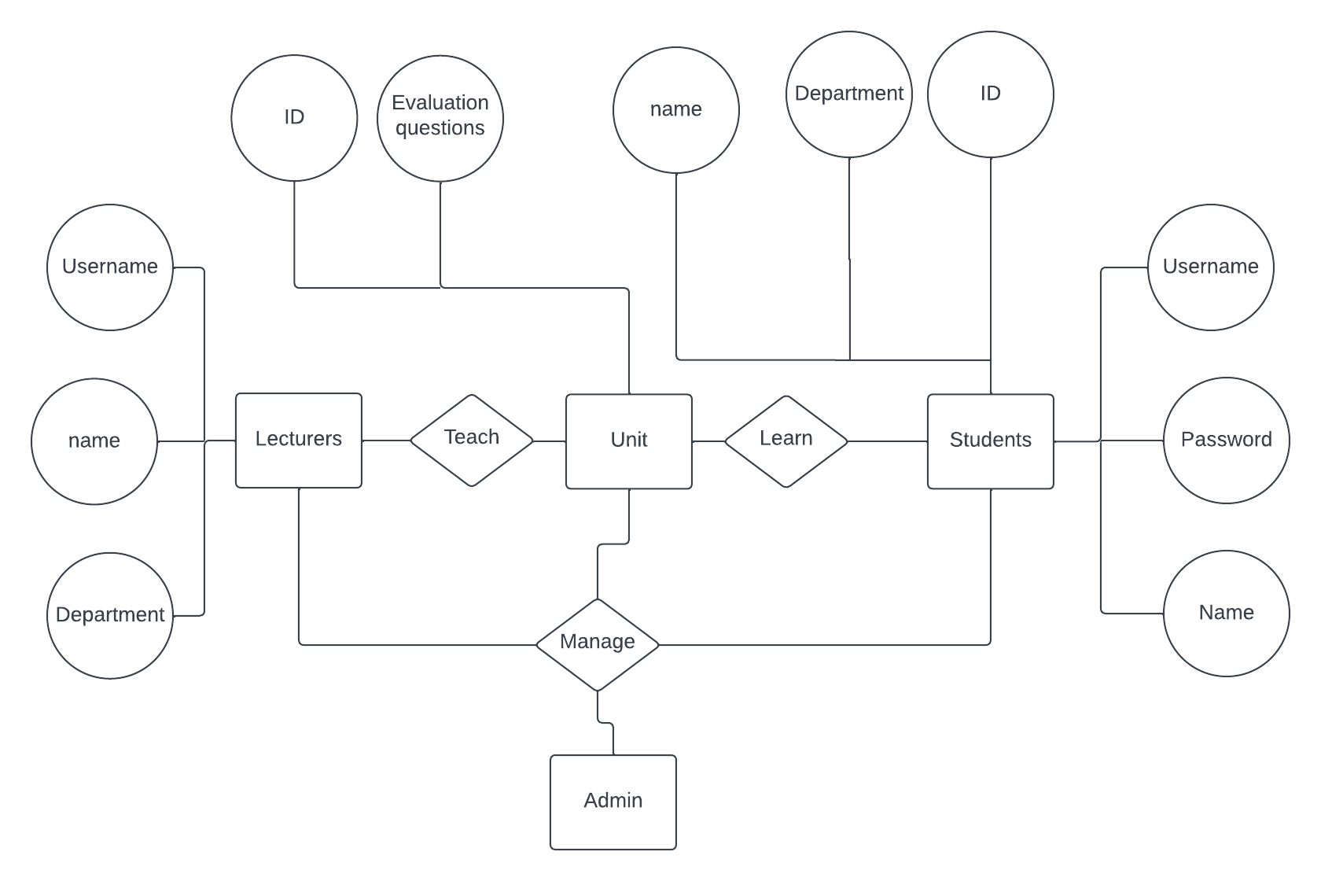

Figure 3 Entity relation diagram

## **3.8 System Testing**

The following tests are going to be performed in the proposed credit card fraud detection system.

1. **Unit testing**-- focus on specific units or components of the software to determine whether each one is fully functional. The main aim of this endeavor is to determine whether the application functions as designed. In this phase, a unit can refer to a function, individual program or even a procedure, and a [White-box Testing](http://stackoverflow.com/questions/402161/black-box-vs-white-box-testing) method is will be used to get the job done. One of the biggest benefits of this testing phase is that it can be run every time a piece of code is changed, allowing issues to be resolved as quickly as possible.
2. **Integration testing—**gives us the opportunity to combine all of the units within a program and test them as a group. This testing level is designed to find interface defects between the modules/functions. This is particularly beneficial because it determines how efficiently the units are running together. Keep in mind that no matter how efficiently each unit is running, if they aren’t properly integrated, it will affect the functionality of the software program.
3. **System testing**--the complete application is tested as a whole. The goal at this level is to evaluate whether the system has complied with all of the outlined requirements and to see that it meets Quality Standards. System testing will be undertaken by independent testers who haven’t played a role in developing the program. System Testing is very important because it will verify that the application meets the technical, functional, and business requirements that were set by the customer.
4. **Acceptance testing**--is conducted to determine whether the system is ready for release. During the Software development life cycle, requirements changes can sometimes be misinterpreted in a fashion that does not meet the intended needs of the users. During this final phase, the user will test the system to find out whether the application meets their business’ needs. Once this process has been completed and the software has passed, the program will then be implemented.

# **CHAPTER4: SYSTEM IMPLEMENTATION AND DEPLOYMENT.**

## **4.1: System description**

In this chapter I will present an insightful overview and implementation of the lecture appraisal platform, focusing on its benefits, implementations, and impact on the educational landscape. The Lecture appraisal system is to be developed to address the critical need for comprehensive and tailored feedback in the evaluation of lectures. By offering user friendly and customizable questions, the system aims to empower lectures and administrators to gather valuable insights from students, fostering a culture of continuous improvement in teaching practices. Through the Lecture Appraisal system, I envision on creating a more engaging and effective learning environment, where student voices are well heard, and administrators can make data-driven decisions to enhance teaching methodologies. The features and capabilities of the Lectures appraisal system can revolutionize the lecture appraisal process, ultimately elevating the quality of education in our institutions.

**4.2 The Admin page**.

### **4.2.1 Reports page.**

This admin page shows reports for students who took part in the appraisal system. The admin can use this information to come up with decisions needed and areas that need to be improved. Note that students reports are anonymous and only lecture information are displayed in the reports. This is to ensure students feel free to express their views. For example from the below screenshot shows appraisal results for lecture identification number 241, in respect to Unit INTE 425, the responses shows how many students responded to the given choices.

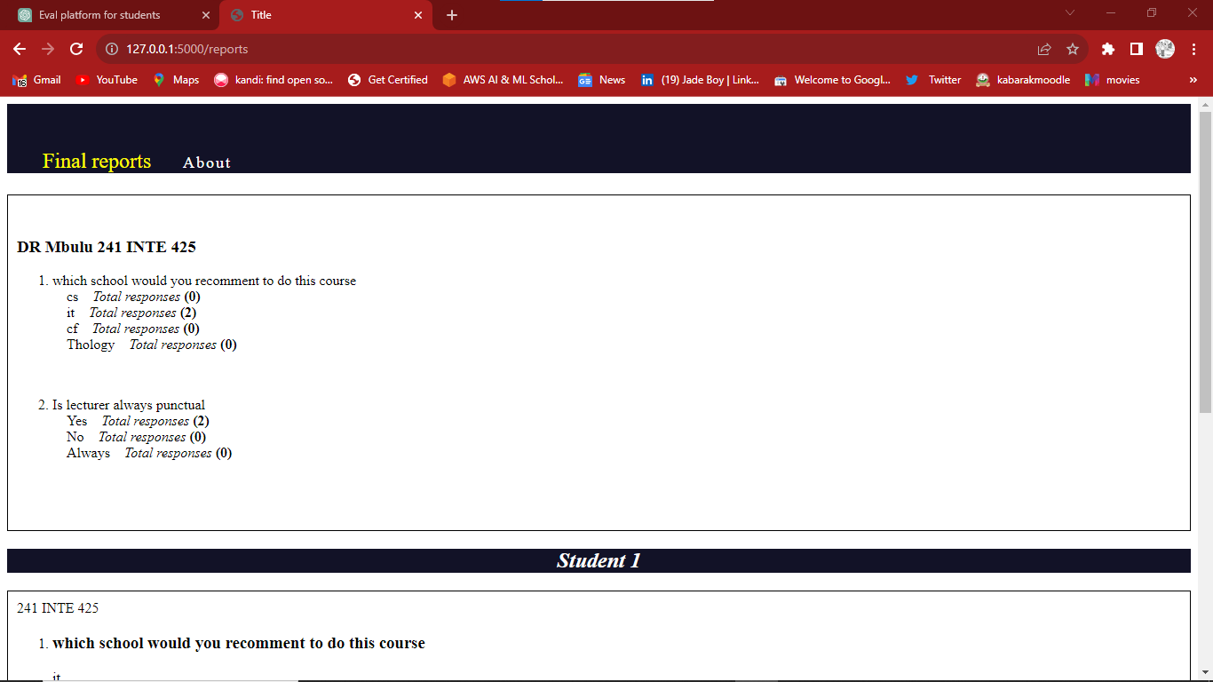

Figure 4Example of reports page

### **4.2.2: lecture and student management page.**

These pages give the admin priority to add and update lecture courses, delete or update students and manage units which certain students can evaluate. On the lecture management page, administrators are granted the utmost priority to efficiently add and update lectures and course assigned to them. This features enables seamless adjustments to course assignment, ensuring that the latest changes are always available. Moreover, the ability to delete or update student records empowers and administrators to maintain accurate and up-to-date student information within, the system. This ensures that students have access to relevant evaluation forms and that their feedback remains meaningful and relevant. Example of lecture page is in the screenshot below.

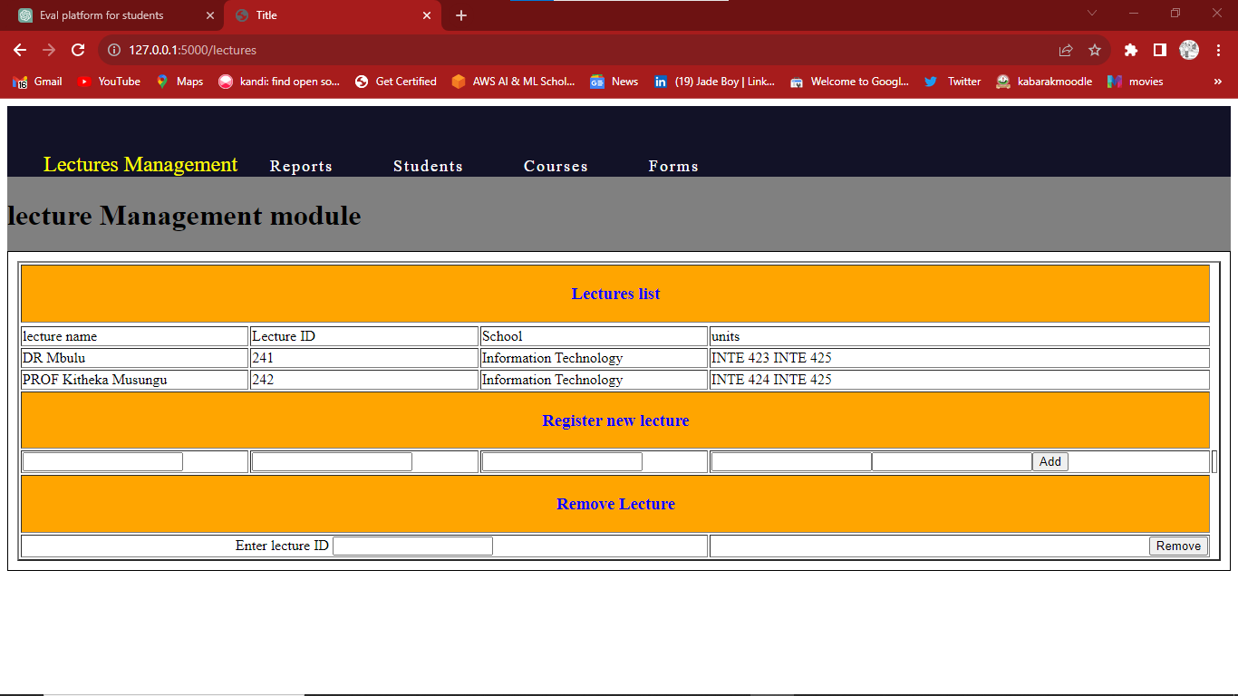

Figure 5 Example of lecture management page

### **4.2.3: Forms page.**

In this page the admin is able to update questions tailored for students for evaluation. This the questions engine with a templates for forms to be defined by the admin. From this page admin can change or update question tailored to certain unit. This page hosts a powerful questions engine that enables admin create, modify and update questions in a user friendly manner. This flexibility allows for inclusion of unit-specific questions, ensuring that students provide feedback that directly pertains to their learning experiences in a particular course. An example of the form page is in the screenshot below

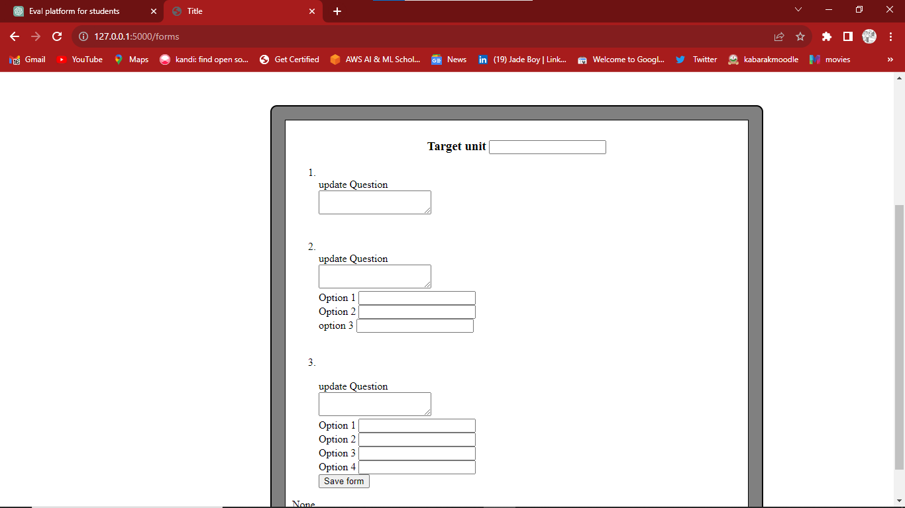

Figure 6 Example of the question template

## **4.3: Student module.**

### **4.3.1 Guidelines page.**

This is the redirection page from login. It contains guidelines and instructions needed before students commence the evaluation process. It serves to remind students to be responsible and rational and constructive feedback. By emphasizing the significance of their evaluations, the guidelines page reinforces the importance of their input in shaping the educational experience. It also includes list of units that the student is allowed to apprise. This makes sure students only access units that they are enrolled to. The example below shows an example screenshot of the guidelines page

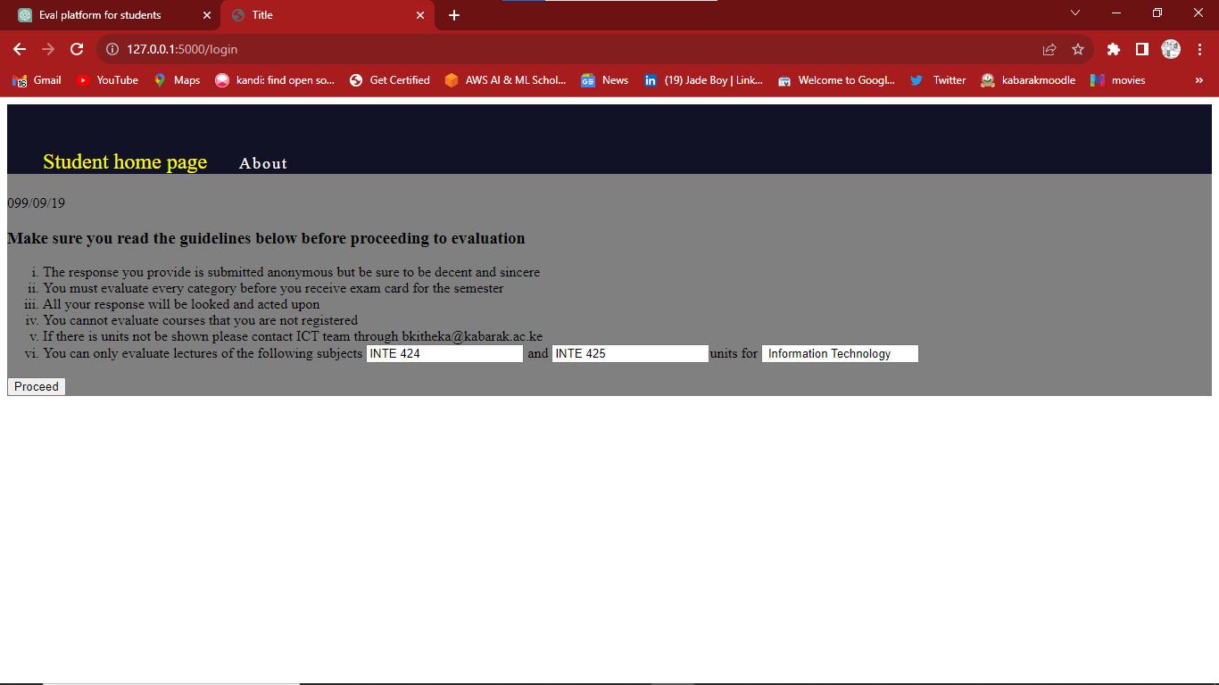

Figure 7 Example of student login page

### **4.3.2 The assessment page.**

This is the appraisal page for students. This allows students to give feedback about lectures on courses they are enrolled in. The questions can range from text boxes, radio questions and many others. Through the assessment page, students can share their experiences, thoughts, and suggestions, contributing to a holistic understanding of the teaching methodologies and course content. The page prompts students to provide feedback on various aspects of the lectures, enabling them to asses the effectiveness of the teaching methods, the clarity of course content, and the overall learning experience. An example of student assessment page is in the screenshot.

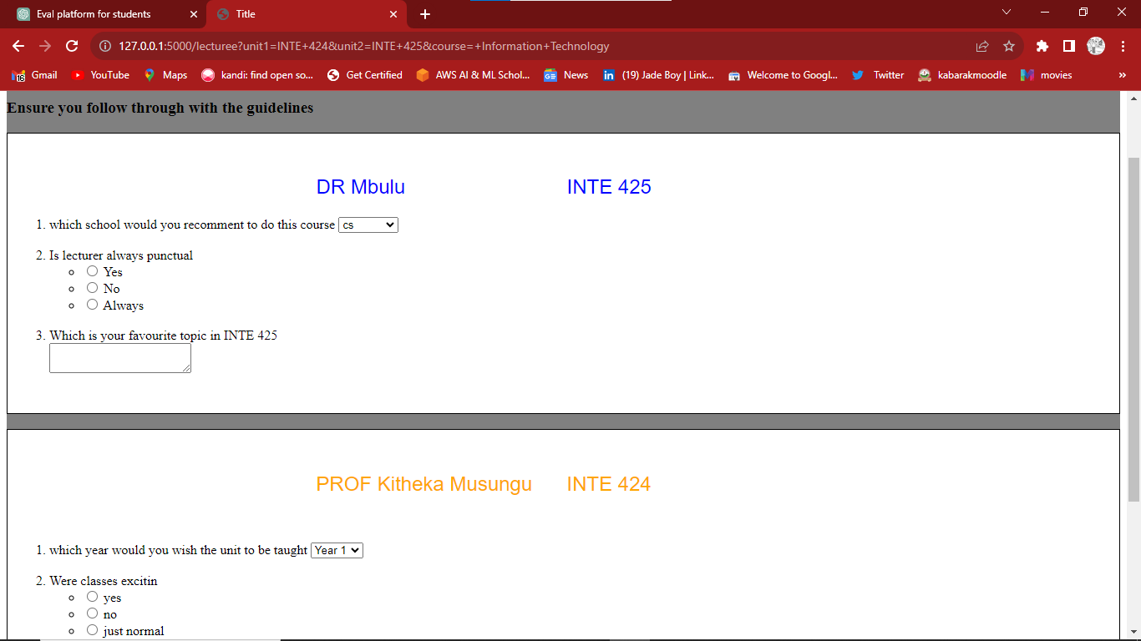

Figure 8 Example of evaluation page

## **4.4 Access Control module.**

The Access control model is a crucial component of the Lecture Appraisal System, ensuring that only authorized students and administrators can access the System. To maintain the systems,s security and privacy, stringent measures are implemented to safeguard sensitive information and restrict unauthorized access.

For students, the process of gaining access to the portal begins when they are added to the system by administrators. Upon registration, each student is provided with a default password, which is temporary key to access the system for the first time. It is important for student to understand that this is default password is only meant as an initial login credential and should be changed immediately after first login.

Moreover, the system incorporates password strength requirements to encourage students to create strong and secure passwords. These requirements may include a combination of lower case letters, numbers and special characters to boost password’s robustness. To prevent data bridges and ensures the security of the Lecture Appraisal System, the admin password will be provided during the installation process. This measure aims to maintain the confidentially of administrative access, adding an additional layer of protection to safeguard sensitive data and maintain system integrity.

# **CHAPTER 5: CONCLUSION AND RECOMMENDATIONS.**

## **5.1: Conclusions.**

In conclusion, the Lecture Appraisal system represents a cutting-edge and innovative solution that addresses the limitations of the paper based evaluation methods and existing online systems. Through its customizable platform, the system empowers administrators to design tailored evaluation questionnaires, aligned with the course content and learning objectives. This customization fosters a culture of data-driven decision-making, enabling comprehensive insights into the teaching methodologies and identifying areas of improvement.

The system also prioritizes student engagement, providing a user friendly interface for student to offer a valuable feedback on their training. By incorporating open ended questions and a range of question formats, the system encourages students to provide detailed and constructive feedback, which contributes to a more holistic understanding of teaching effectiveness. Furthermore, the system streamlines the appraisal process, automating data aggregation and analysis, saving valuable time for administrators.

In conclusion the Lecture Appraisal system serves as a powerful tool for enhancing the quality of lecture evaluations, promoting continuous improvement in educational institutions, elevating the overall experience for students. Through its comprehensive and customizable approach, the system represents a game –changer in the field of educational assessments and demonstrates its potential to transform the way educational institutions gather, analyze and utilize feedback to drive academic excellence.

## **5.2: Recommendations.**

For future studies and research on appraisal systems, several areas can be explored to further enhance the effectiveness and impacts on educational institutions. Some include; conducting studies to assess the long term effects of the lecture appraisal system on teaching practices and student outcomes, in depth user experience research to understand the perspectives and needs of both administrators, students and lectures, exploring the integration of AI technologies in the system to automate and enhance data analysis, identify patterns and generate personalized feedback, and investigate further measures to strengthen data privacy and security in the system.

## **5.3: Appendix.**

### **5.3.1:Appendix1- References**

Johnson, M.(2018). Enhancing the quality of Lecture Evaluations: A comprehensive Approach. Journal of higher Education, 78-95.

Smith, A., and Williams, B.(2019). Streaming the Appraisal process. Transitioning to online evaluation Systems. Educational Review, 112-128.

Brown, C, and Lee, D(2020). Data driven Decision –Making in education: A comparative study. Journal of educational research, 200-215.

Johnson, m.(2022). Enhancing lecture evaluations through tailored questionnaires: A case study Educational technology review, 225-238.

### **5.3.2 Appendix 2- Project Schedule.**

|  |  |  |  |  |
| --- | --- | --- | --- | --- |
| Task | Duration | | | |
| May | June | July | August |
| Data collection and analysis |  |  |  |  |
| Project implementation |  |  |  |  |
| Project progress reports |  |  |  |  |
| Project Testing |  |  |  |  |
| Project presentation |  |  |  |  |

Table 1Project schedule

### **5.3.2: Appendix 3- Project budget**

|  |  |  |  |
| --- | --- | --- | --- |
| Requirements | Price per item | Quantity | Total |
| Software development tools | N/A | N/A | $5 |
| Research material e.g. Internet. | N/A | N/A | $6 |
| Notebook | $0.7 | 1 | $0.7 |
| Transport | N/A | N/A | $3 |

Table 2 Project Budget